How I launched 40 quests resulting in 111K activations
In Web3, attention is easy to buy. Adoption is not.
Quests close that gap. They turn “I heard about this protocol” into a guided set of actions that prove usage, validate completion, and reward the right behavior.
Towards the end of last year, I launched 40+ quests across major platforms, resulting in 111K+ unique activations. The work was built as a repeatable system, where each quest is treated like a mini product launch.

Table of Contents

Resources Overview
- Project Discovery - Find projects to create quests
- Quest Enrichment - Research the project and find links and information
- Quest Building - Setup the first draft, use the quest builder, and get the quest reviewed
- Quest Promotion - After publishing the quest, promoting the quest for user adoption

What Are Quests
- Intro - Short introduction
- Quest Journey Overview - Completing quests

Types of Quests
- Quest Actions - On and Off-chain actions
- Platforms - Where can you find quests?

Why Quests Matter
- Why Users LOVE Quests - People who complete quests regularly
- Why Projects LOVE Quests - Projects that build quests
- Why Quest Platforms LOVE Quests - Platforms that publish quests
- Why I LOVE Quests - What do I love about quests?

How I build quests
- Project Discovery - Strong fit shortlist - Meaningful first use
- Project Enrichment - Full research pack - Test like a user
- Referral Setup - Trackable referral link - Verify with second wallet
- Functional Testing - Confirmed working flow - Minimum viable transaction
- Quest Doc Build - Clear card-by-card steps - Zero ambiguity wording
- Quest Preview Image - Consistent quest creative - Clean template system
- Native Quest Builder - Verified tasks live - Chain and contract checks
- Review and Approval - Quest goes live - Fast feedback loop
- Promotion - Distribution in community - High-intent visibility
- Monitoring - Keep an eye on the referrals and future airdrop

Resources Overview:
Many resources were generated for the purposes of:
- Project Discovery - Find projects to create quests
- Quest Enrichment - Research the project and find links and information
- Quest Building - Setup the first draft, use the quest builder, and get the quest reviewed
- Quest Promotion - After publishing the quest, promoting the quest for user adoption

Where to find all my resources:
- Resources tab - Within this portfolio
- All Quest Portfolio Resources - Within this google sheet
- Throughout this Summary - See below

All Quest Resources - All Quest Portfolio Resources

What Are Quests?

Intro
A quest is an interactive onboarding and growth campaign that blends on-chain actions, offchain actions, and verification with rewards.

Think of it as a structured user journey.

Instead of asking someone to “go try the product,” you give them a clear path to the first meaningful outcome.

Quests are new incentive-based user experience which incentivize users and use gamification for them to experience your product.

Often involving several audiences and with many variations, quests provide a unique way to engage with platforms and websites.

Quest Journey Overview:
Just as the nature of technology is to evolve, so does the user.

Quests are also always in a state of evolution because users are constantly seeking out new and novel experiences.

The best quests give users quests of varying sophistication and actions. Why?
Quest Variables:
- Experience Levels - Inexperienced users vs experienced degens
- Repetition - Too many of the same quests = users leave and never return
- Novelty - Providing a narrative or novelty to follow throughout the process keeps people engaged
- Scoreboard - Giving a dashboard for users to compete and watch their points (or rewards grow)
- Extra Earning Potential - Give users hidden ways to earn (referral generation multiples, secret phrases, and easter eggs)

Quest Start to Finish
- Find a quest on a quest platform
- User opens the quest
- User completes actions (On-Chain and Off-Chain)
- Rewards unlock upon completion

Differentiation Between Quest Platforms
- Every platform is different
- Certain types of users are drawn to some
- Reduction of bots is an ongoing fight
- Always remember to be smart about connecting to quests (Separate wallet when possible)

There are many different quest platforms, here are just a few of the most well known quest platforms:
Quest Platforms - Project Discovery[Sheet]

Types of Quests
Usually quests I build come in a few variations of quest “types”

On-Chain Activity - Sign Up and Complete a transaction:
Certain types of projects such as dexes, per dexes, lending protocols, etc want users to interact with the smart contract to show user participation.

So there are plenty of instances where users are required to swap, add liquidity, mint, lend, borrow, etc.
- Haiku - https://app.haiku.trade?r=klint
- Cables Finance - https://app.cables.finance/?referral_code=noadfV7gdm
- Loopscale - https://loop.sl/i/xYphD

Campaign Quests - Sign Up and Participate:
Many projects have a native quest setup built out of an onboarding process with gamified elements such as points, levels, multipliers, and expiring initiatives which require daily or weekly interactions to drive up points as part of a competition.

These platforms can have dashboards and push users to interact with a wide variety of on-chain (swap, mint, bridge, etc) and off-chain activities (like, comment, retweet on x).

Some projects can even be in testnet and will encourage users to use the faucet.
- Ducate - https://app.ducatprotocol.com/quanta?referral=p6Rtob3uaYQY
- ZenChain - https://zenquest.zenchain.io/?referral=Ta_pekpSUMt46A79Y-doG1TYnxb0DR3L86J2yUVIokk
- Syntekika - https://syntetika.io/hub?ref=uHDKaUAf

Creator Platforms - Sign Up and Create
Some platforms reward users for “yapping” or publishing content. Users are encouraged to join the platform and promote a specific campaign, project, or make something original to potentially earn something by doing it.
- ScribbleDao - https://app.scribbledao.com/?referrer=ca4470b2
- Zoop - https://app.zoop.club/sign-up/ref07491081?mode=creator

Depin Product Quests- Sign Up and Earn
Often these campaigns require users to download or add products to their browser to earn points passively in the background. This can be social points or Depin projects.
- Membit - https://hunter.membit.ai/?code=GFHIIPIX
- Bless - https://bless.network/dashboard?ref=QSUP2A

Promote Blockchain Products - Sign Up and Pay to Earn
Some quests require upfront investment to use the platform or tool.
This can be infrastructure projects that allow people to run their own nodes or even centralized exchanges that encourage users to go through KYC and buy crypto.
- Nodes Garden - https://nodes.garden/s/KLINT

Quest Actions:
Complete quest actions to claim rewards.

Types of Quest Actions:
- On-chain - Swap, Deposit, Provide liquidity, Stake, Lend, Borrow, Bridge, Mint, Vote, etc
- Off-chain - Open Link, (Go to website, Read docs, Watch a tutorial, etc), Complete a quiz, follow on social media, join community (discord or telegram), Engage with campaign posts, Contribute on GitHub, etc
- Rewards - Unlock upon completion - Mint NFT, Points, Token reward, etc

Why Quests Matter

Why Users LOVE Quests
Quests reduce confusion and increase confidence.
- Learn by doing - Better appreciate of crypto via exposure to new projects
- Faster first success - a guided on-chain experience
- Less fear of mistakes - Genuine projects with real rewards
- Progress feels measurable - Each quest is gamified
- Reputation becomes portable - Show your score and get into the community

Why Projects LOVE Quests
Quests are a performance channel built around outcomes.
Instead of optimizing for impressions, teams can optimize for verifiable actions: first swap, first deposit, first vote, first bridge.
- Higher intent users - Real users using real liquidity
- Faster time to activation - Quest promotions = Fast turnaround time
- Guided “aha” moments - Provide genuine experiences and favorite tools
- Cleaner attribution signals - Referral URLs, UTM links, and traffic spikes for quests
- Better lifecycle sequencing - Create campaigns which have increased on-chain activity
- Community flywheel effects - Introduce users to more of your project, community, and future roadmap

Why Quest Platforms LOVE Quests
Platforms provide the rails that make quests scalable.
They standardize task formats, verification flows, reward delivery, and discovery. That infrastructure is why quests can function as a reliable growth motion, not just a one-off campaign.
- Task templates at scale - Quest volume = greater predictability and more incentives
- Verification tooling - Consistently validate users and activities
- Reward distribution systems - Create incentives for more activity and increase overall growth
- Leaderboards and sprints - Competition and gamification elements
- Analytics and admin workflows - Incredible granular tracking and testing

Why I LOVE Quests
My motivation is simple: quests are where growth, product, and community meet.
I like work that is measurable, user-first, and hard to fake. Building quests forces precision: every link, instruction, proof, and reward mechanic has to hold up in the real world.
- Adoption focused writing - Practice promotion and “what’s in it for me” writing
- Funnel and UX thinking - Greater appreciation for better user experience and product-led growth
- Proof based growth loops - Clear demonstrations of real-world gamification and user triggers resulting in better conversions
- High standards testing - Set a high bar with consistency
- Clean execution under constraints - Go from manual, To somewhat automation, to 90% automated.
Quest Activations on Layer3: 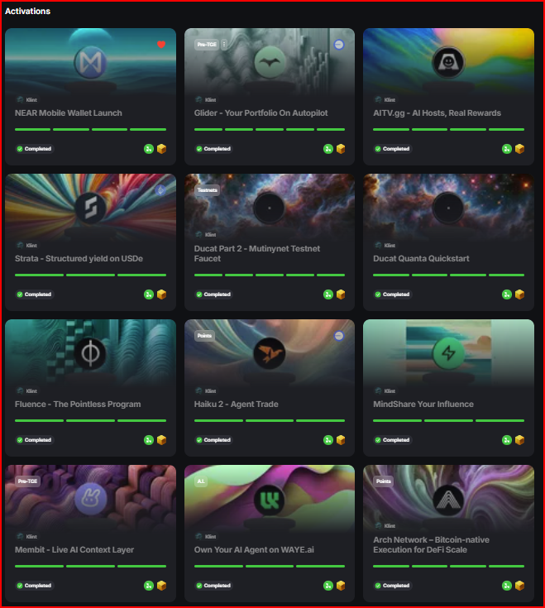

How I Build Quests
Project Discovery
I source projects where quests can create meaningful first use, not just clicks.

You need to know what you’re looking for, where to find it, and what “good” looks like.

Finding new projects is a game of speed.
Using a variety of tools, you can find projects across channels before the world is talking about it.

Search Terms:
- Search Terms - Search Terms - Airdrop[Sheet]

Discovery by Channel
- Airdrop and campaign trackers - Airdrops and ICOs[Sheet]
- Recently funded lists - Funding, Quests, and Discovery[Sheet]
- Accelerator cohorts - Accelerator Programs [Sheet]
- Pitch competition lists - Pitch Competition Listing and Directories[Sheet]
- Crypto Events - All Crypto Event Directories[Sheet]
- Hackathon Directories - Hackathon Directories - Web3, Blockchain, Crypto[Sheet]
- Funding Feeds - Funding Feeds[Sheet]
- Quest Platforms - Quest Platforms - Project Discovery[Sheet]
- Telegram Airdrop - Telegram Airdrop Channels[Sheet]
- X Airdrop Alerts - X / Twitter - Airdrop Alerts[Sheet]

Selection and Prioritization Criteria:
- EVM or Solana Ecosystem - More familiarity and greater adoption
- Functionality - Product works and on-chain activity exists
- Doxxed Founders - Real team with real profiles (Less likely a scam or rug)
- Funding - Did this project get funding - Does the project momentum
- External Audit - Real web audits done by reputable companies
- X Activity - Does this project have genuine and consistent posts on or/ Discord
- Referral Link - Does the this platform allow me to create a referral link and can get credit for referring users
- Smart Contract - Is the smart contract legit - Use de.fi or arkhamintelligence
- Transactions Volume - Are there many transactions (Daily, Weekly, Monthly) associated with the smart contract

Collection:
- Fast Collection - for further review - Quest Collection[Sheet]
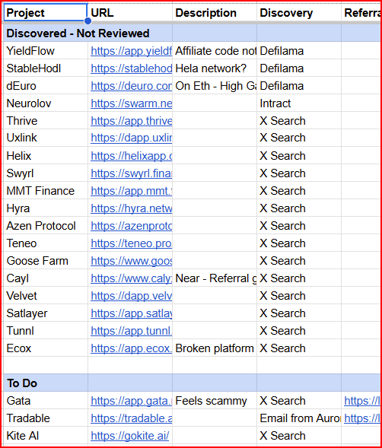

Project Enrichment
Before writing a single task, I map the protocol like a marketer and test it like a user.
Research checklist:

Web URLs
- Homepage and product pages
- Documentation, litepaper, whitepaper
- Blog, Medium, and News sections

Application / Platform
- Core App URL
- Referral
- On-Chain Actions
Social Media and Community
- X / Twitter
- Discord
- Telegram
- Quest, Airdrop, or Campaign Specific Posts

Resources:
- Deep Research LLM - Perplexity,
- Prompt - Quest Project Research - Prompt- Quest Project Research[Doc]
- Quest Template - Google Doc - Template - Quest Template[Doc]
- Quest Enrichment - Add Research to Sheet - Quest Enrichment[Sheet]

Example: Using Perplexity to enrich projects
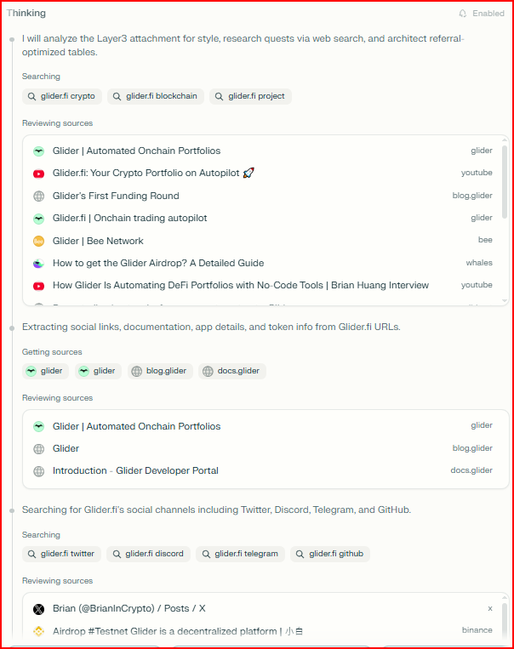

Referral Setup
Most projects understand viral loops and referral dynamics.

It’s also incredibly easy to vibe-code a unique link builder for all users these days.

If a project has a referral mechanism, I generate a tracking link early.
Referral links give me a chance to earn something on top of the quest.

Referral links create attribution and allow me to track my incentive structure for sustained promotion.

Referral best practices:
- Complete Registration
- Find the Referral Link Generator
- Create / Get Unique Referral LINK
- Test Link (Sign Up with a secondary wallet)
Example - Velvet Trade - https://dapp.velvet.capital/Referral/1
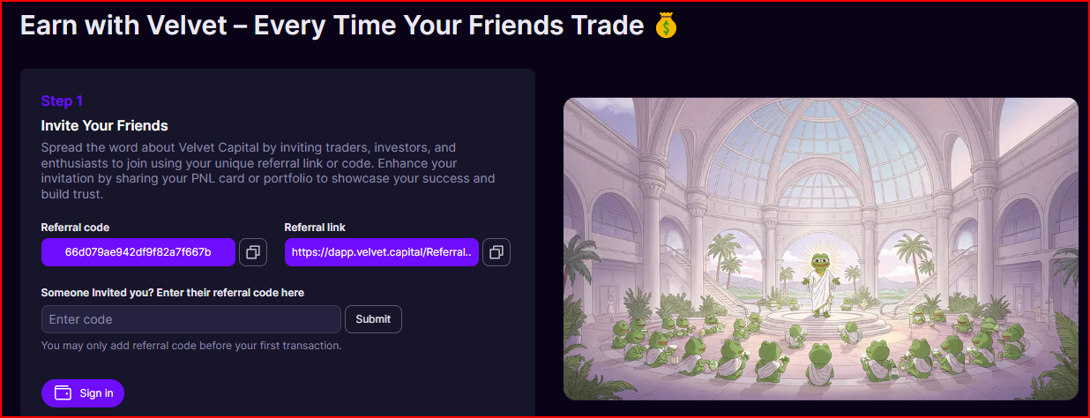

Functional Testing
Testing is where good quests stand out.
I complete every step exactly as a new user would.

Testing standards:
- What actions can be done)
- Does it work (On-Chain)?
- Is it easy (Beginner - Medium)?
- What is the minimum viable transaction
- Confirm positive result (Points or rewards earned)
- Clear time estimates per step

Overview:
Write a few short sentences describing how this was done.

Quest Doc Build
In a Google Doc, Build your quest with the following:

Resources:
- Project Links and Raw Data - Quest Enrichment[Sheet]
- LLM + Deep Research / Internet Access
- Prompt - Quest Creation Prompt - Quest Prompt[Doc]
- Quest Template - Google Doc - Template - Quest Template[Doc]

Wordsmithing, Adjustments, and Review:
- Protocol Metrics and Details
- Instructions
- Links
- Cards

Most of the time, the LLM (Perplexity), found the web URLs and most of Social Media and community links.

Example
The Autopilot Quest[Doc] - Draft built in a Google Doc
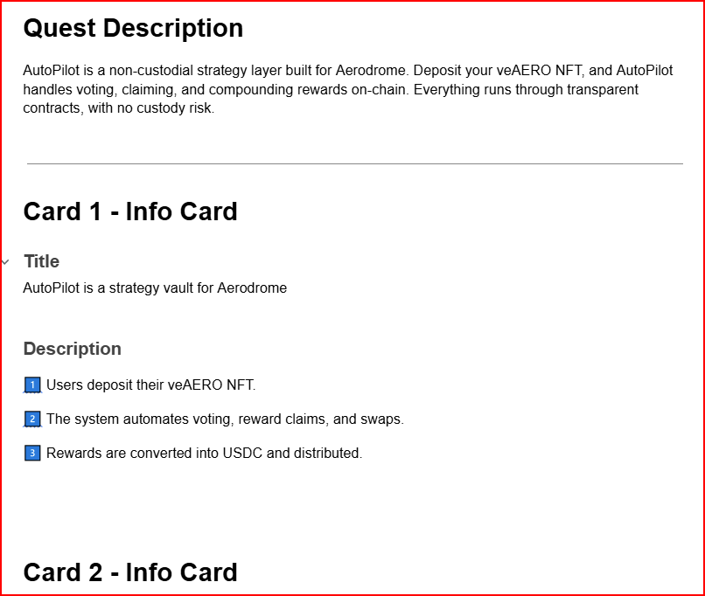

Quest Preview Image
Collect your assets and use a simple template.

Find the logo, make a background, and add it to the template in Photopea.

Tools:
- X / Twitter - Find Logo
- Photopea - Use .PSD template
- LLM + Prompt - Create background photo

Assets:
- Project Logo - Usually found on X / Twitter Profile
- Background - Generate a background (Landscape) using LLM
- Template - .Psd Template
- Photopea - Add Layer Mask over template + Add background

Example - Bless PNG - Bless - quest logo psd.psd[PSD]
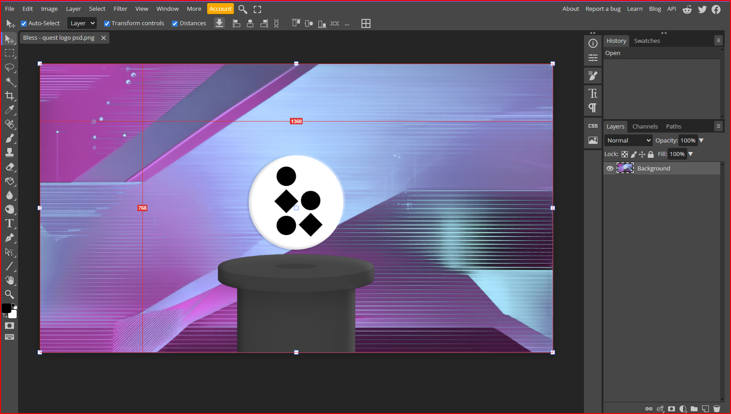

Finally, export and upload to the quest platform.

Native Quest Builder
Most quests were implemented in the platform’s builder, especially Layer3.

Layer3 has excellent documentation and support in the builder activation documentation.

Quest Overview:
- Core Quest Details - Quest name, description and URL structure
- Chain Selection - Solana vs EVM
- Type - Niche or Project category
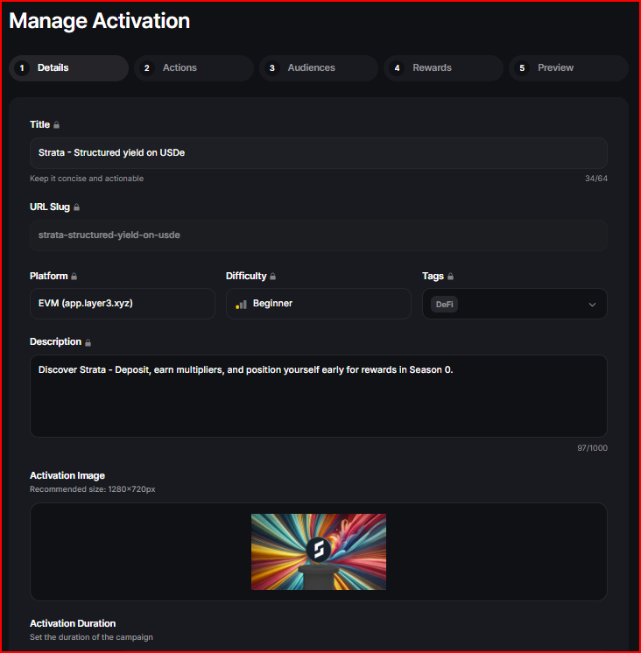

Card sequencing - Info cards:
- About the Project / Protocol
- About the quest
- Potential rewards
- Format - Be concise and tight
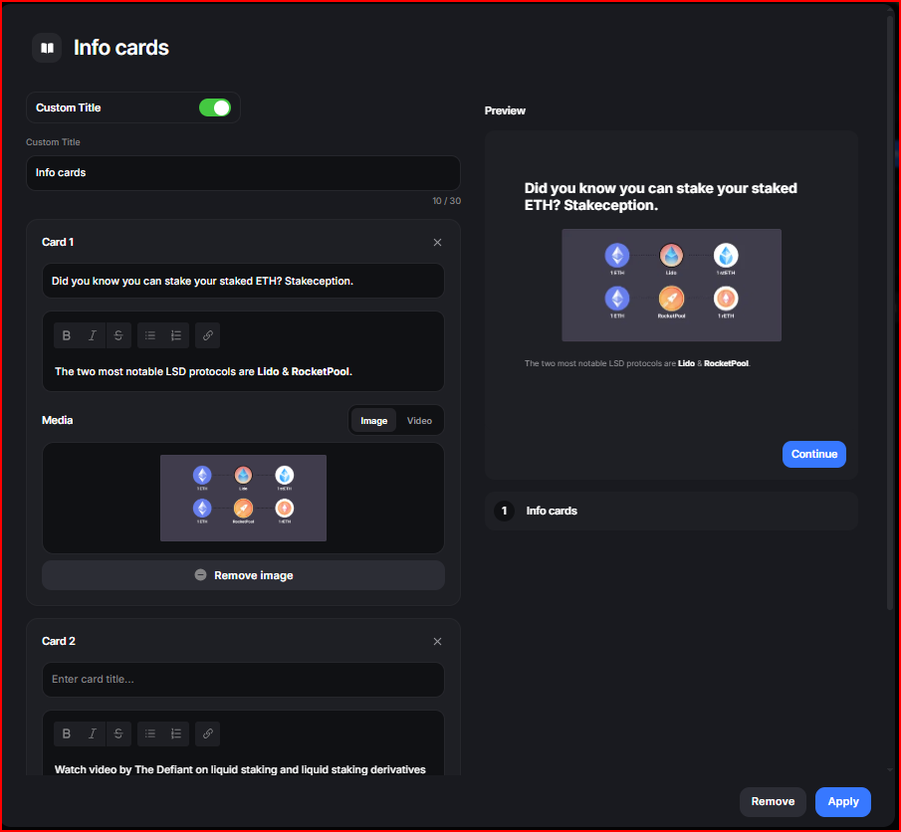

Onchain Activity
- Chain Selection
- Smart contract Identification
- Testing / Transaction Validation
- Validation Details - Time, Minimum Amount, Specific Token, etc
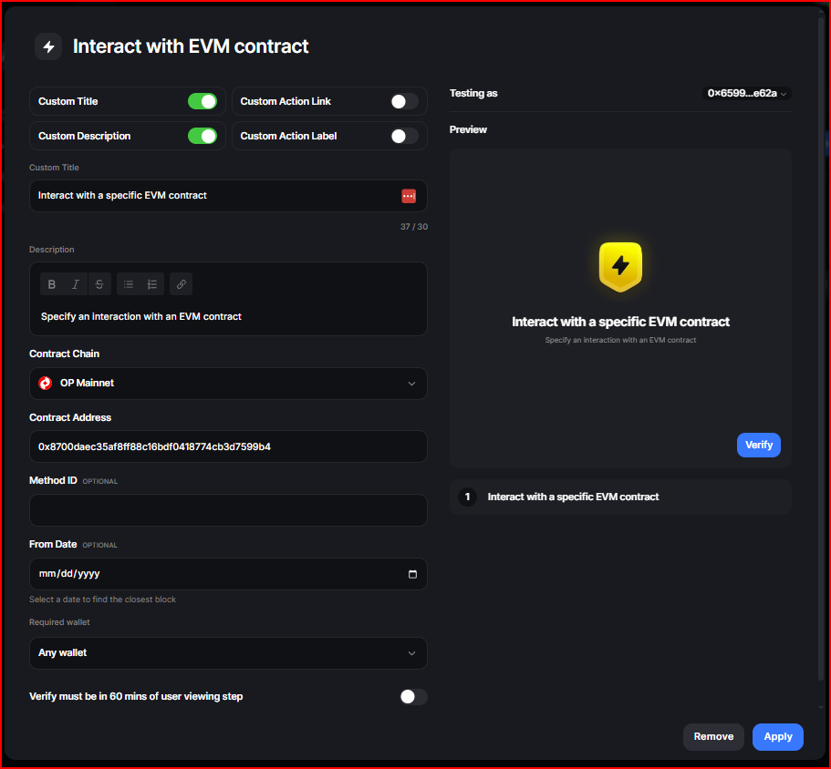

Off-chain activity
- Open Link (View Website, Video, Blog, Post)
- Join Community
- Like, Comment, and Retweet
- Follow on X
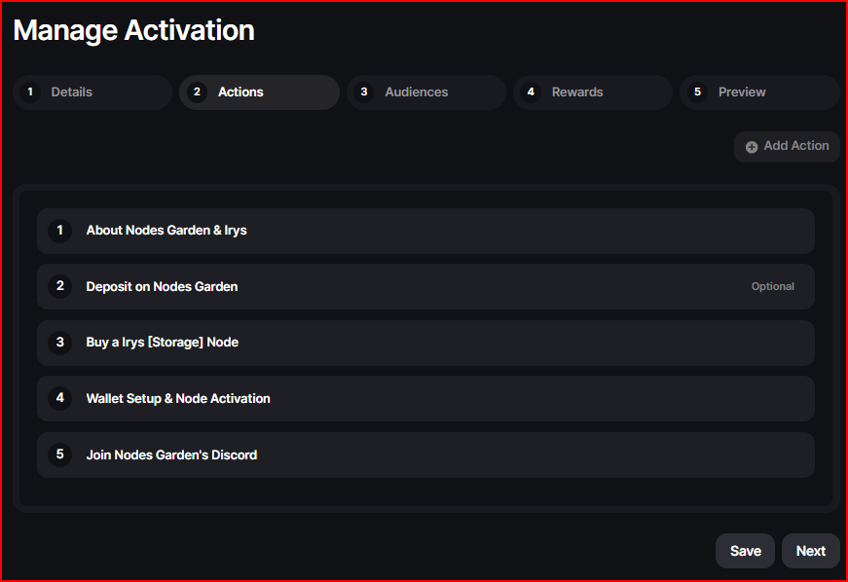

Resources
- Quest Draft - Google Doc (Specific to this quest)
- Preview Image - PNG with Company Logo and background
- Links - Referral, SoMe, Community, Documentation, Etc
- Screenshots - Steps, Actions, Platform, etc

Review Checklist
- Flow - Does it make sense and work
- Link review - Referral link, SoMe Or Community
- Wordsmithing - Easy to read and follow
- Format - Clean and concise - minor adjustments on titles and descriptions

The goal was always the same: keep users moving, keep proof clean.

Review and Approval
After completion of the quest inside of the builder, I submit it inside of the platform.

Sometimes I would publish multiple quests in the same day.

Using a telegram group, I write to a few moderators and ask for feedback.
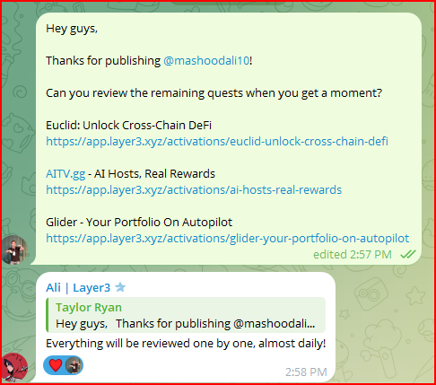

The moderators would review the quest and sometimes provide feedback.

Feedback would almost always be minor and the quest would go live within 1-2 business days.

Promotion:
After the quest was published on layer3, I would amplify the reach of the quest by doing the following:

Post the Quest on my own X
- Tag the Project
- DM the Channel and Team (if possible)
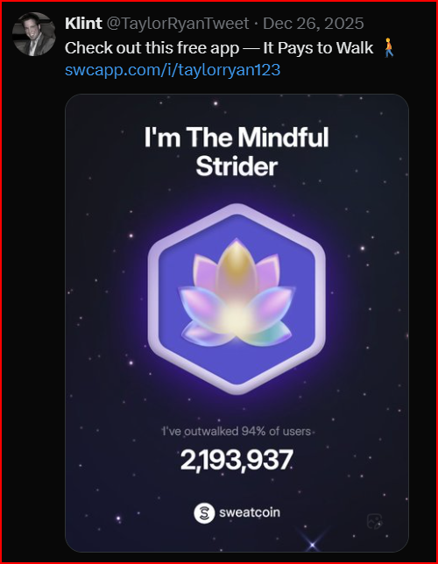

Join the Community (Discord or Telegram)
- Post in a general channel asking if people from the community had seen it yet
- Create a ticket and ask the moderators to post about it.

Resources
- Prompt - Quest Promotion - Prompt - Quest Promotion - Portfolio[Doc]
- Prompt - Quest Promotion - Prompt - Written Posts - Quest Promotion - Portfolio[Doc]

Monitoring
On-occasion, I’ll check back on the project to see:
- How my referral earnings are going
- Project developments
- Airdrop claim - Free money
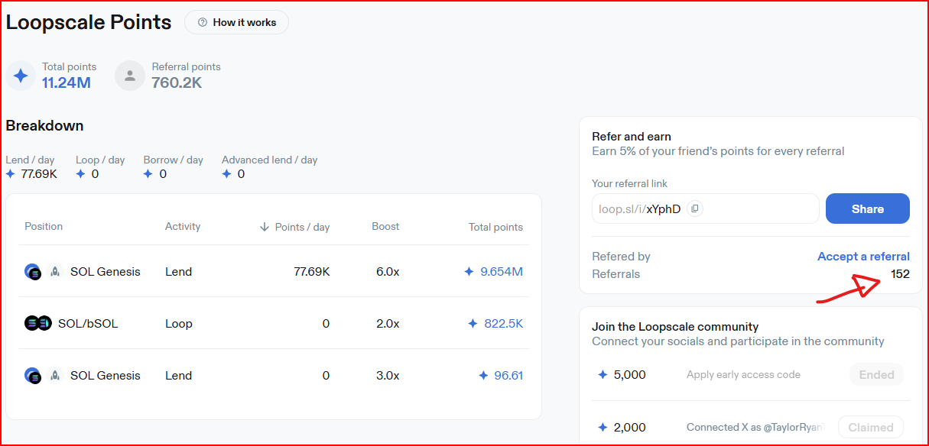

Conclusion
The 111K+ activations did not come from guesswork.

They came from a launch system designed to remove friction, protect proof quality, and make completion feel obvious.

In many cases I would receive points every time someone clicked through a quest link and signed up.

Additionally, Layer3 gave me kickbacks for publishing quests.

Sometimes the projects might give me a small kickback for my trouble.

My Results
Layer3 had a very active community and anyone could publish quests
- 39 of my quests went live on Layer3
- More than 111,000 activations in total
- 2500 - 3500 activations per quest
- Generated $32K in Rewards

My Repeatable Quest Launch System
- Project Discovery - Strong fit shortlist - Meaningful first use
- Project Enrichment - Full research pack - Test like a user
- Referral Setup - Trackable referral link - Verify with second wallet
- Functional Testing - Confirmed working flow - Minimum viable transaction
- Quest Doc Build - Clear card-by-card steps - Zero ambiguity wording
- Quest Preview Image - Consistent quest creative - Clean template system
- Native Quest Builder - Verified tasks live - Chain and contract checks
- Review and Approval - Quest goes live - Fast feedback loop
- Promotion - Distribution in community - High-intent visibility
- Monitoring - Keep an eye on the referrals and future airdrop

My Method Works
What clients and teams get from this approach
- Faster onboarding - First to value
- Stronger verification - Fewer farmers
- Better completion - Clarity
- Campaigns built - Real usage
- Launch process - Scalable

If you want onboarding that feels crisp, measurable, and genuinely useful to users, quests are one of the best tools Web3 has.

The difference is execution. That’s the part I’ve systematized.

